**Name** **-** Sushant Balu Patil **Roll No**  **-** 62

**Class –** T.Y.BTech **Batch -** T3

**Experiment No : 1**

using System;

using System.Collections.Generic;

using System.Linq;

using System.Text;

using System.Threading.Tasks;

namespace hello__world

{

internal class Program

{

static void Main(string[] args)

{

Console.WriteLine("Hello World !");

Console.ReadLine();

}

}

}

**Output:**

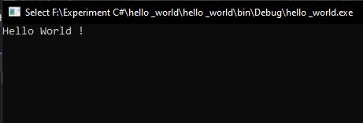

**Name** **-** Sushant Balu Patil **Roll No**  **-** 62

**Class –** T.Y.BTech **Batch -** T3

**Experiment No : 2**

using System;

using System.Collections.Generic;

using System.Linq;

using System.Text;

using System.Threading.Tasks;

namespace Name

{

internal class Program

{

string Full_Name = "Sushant Balu Patil";

static void Main(string[] args)

{

Program Name = new Program();

Console.WriteLine(Name.Full_Name);

Console.ReadLine();

}

}

}

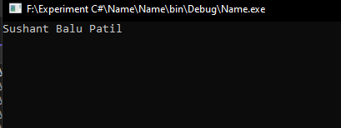**Output:**

**Name** **-** Sushant Balu Patil **Roll No**  **-** 62

**Class –** T.Y.BTech **Batch -** T3

**Experiment No : 3**

**Inheritance.**

using System;

using System.Collections.Generic;

using System.Linq;

using System.Text;

using System.Threading.Tasks;

namespace inherit

{

class Input

{

protected int Width;

protected int Height;

public void SetWidth(int w)

{

Width = w;

}

public void SetHeight(int h)

{

Height = h;

}

}

class Rectangle : Input

{

public int GetArea()

{

return Width * Height;

}

}

internal class Program

{

static void Main(string[] args)

{

Rectangle obj = new Rectangle();

Console.WriteLine("Enter Width:");

int width = Convert.ToInt32(Console.ReadLine());

obj.SetWidth(width);

Console.WriteLine("Enter Height:");

int height = Convert.ToInt32(Console.ReadLine());

obj.SetHeight(height);

int area = obj.GetArea();

Console.WriteLine("Area: " + area);

Console.ReadLine();

}

}

}

**Output :**

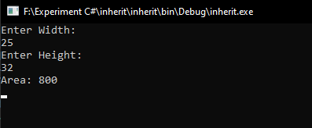

**Name** **-** Sushant Balu Patil **Roll No**  **-** 62

**Class –** T.Y.BTech **Batch -** T3

**Experiment No : 4**

**Calculator**

using System;

using System.Collections.Generic;

using System.Linq;

using System.Text;

using System.Threading.Tasks;

namespace Calculator

{

internal class Program

{

static void Main(string[] args)

{

Console.WriteLine("================ Calculator ===================");

Console.WriteLine("Enter First Number : ");

int num1 = Convert.ToInt32(Console.ReadLine());

Console.WriteLine("Enter Second Number : ");

int num2 = Convert.ToInt32(Console.ReadLine());

Console.WriteLine("================================================");

Console.WriteLine("1.Addition\t\n2.Substraction\t\n3.Multiplication\t\n4.Division");

Console.WriteLine("================================================");

Console.WriteLine("Enter Your Choice : ");

int ch = Convert.ToInt32(Console.ReadLine());

switch(ch)

{

case 1:Console.WriteLine("Addition Of Two Number Is : " + (num1+num2));

break;

case 2:Console.WriteLine("Substraction Of Two Number is : "+(num1-num2));

break;

case 3:Console.WriteLine("Multiplication Of Two Number is : " + (num1 * num2));

break;

case 4:Console.WriteLine("Division Of Two NUmber is : "+(num1 / num2));

break;

default: Console.WriteLine("Enter valid Entry !");

break;

}

Console.ReadLine();

}

}

}

**Output :**

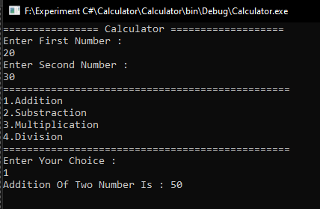

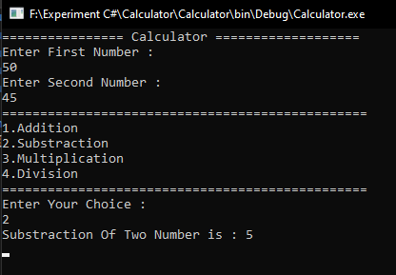

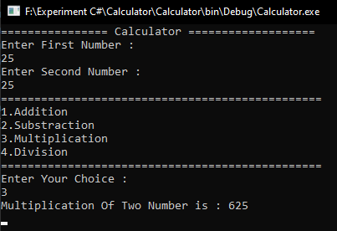

**Name** **-** Sushant Balu Patil **Roll No**  **-** 62

**Class –** T.Y.BTech **Batch -** T3

**Experiment No : 5**

**1. if-else**

using System;

using System.Collections.Generic;

using System.Linq;

using System.Text;

using System.Threading.Tasks;

namespace Control_Statements

{

internal class Program

{

static void Main(string[] args)

{

Console.WriteLine("Enter Your Age : ");

int age = Convert.ToInt32(Console.ReadLine());

if (age > 18 ) {

Console.WriteLine("You can Open Your Linkdin Account.");

}

else

{

Console.WriteLine("You can not Open Your Linkdin Account.");

}

Console.ReadLine();

}

}

}

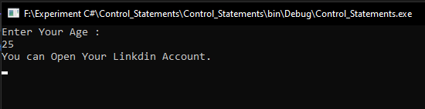**Output :**

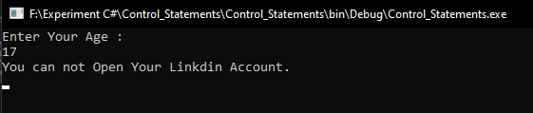

**2.** **Nested if else**

using System;

using System.Collections.Generic;

using System.Linq;

using System.Text;

using System.Threading.Tasks;

namespace Control

{

internal class Program

{

static void Main(string[] args)

{

Console.WriteLine("Enter Your Marks : ");

int Marks = Convert.ToInt32(Console.ReadLine());

if(Marks >=90 ) {

Console.WriteLine("You Got A Grade.");

}

else if(Marks >= 75)

{

Console.WriteLine("You Got B Grade. ");

}

else if (Marks >= 60)

{

Console.WriteLine("You Got C Grade. ");

}

else

{

Console.WriteLine("You Got D Grade. ");

}

Console.ReadLine();

}

}

}

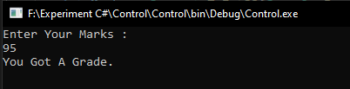**Output :**

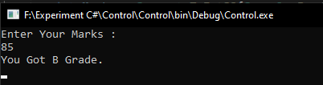

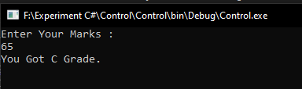

**3.while**

using System;

using System.Collections.Generic;

using System.Linq;

using System.Text;

using System.Threading.Tasks;

namespace Pattern

{

internal class Program

{

static void Main(string[] args)

{

Console.WriteLine("Enter Number Of Row :");

int n = Convert.ToInt32(Console.ReadLine());

int i = 0;

while(n > i) {

int space = 0;

while(space<n-i-1) {

Console.Write(" ");

space++;

}

int j = 0;

while(j < i+1) {

Console.Write("* ");

j++;

}

Console.WriteLine();

i++;

}

Console.ReadLine();

}

}

}

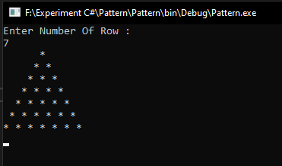**Output :**

**4.Do while**

using System;

using System.Collections.Generic;

using System.Linq;

using System.Text;

using System.Threading.Tasks;

namespace Do_While

{

internal class Program

{

static void Main(string[] args)

{

int i = 1;

do

{

Console.WriteLine(i);

i++;

}

while (i > 10);

Console.ReadLine();

}

}

}

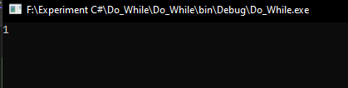**Output :**

**5. Switch**

using System;

using System.Collections.Generic;

using System.Linq;

using System.Text;

using System.Threading.Tasks;

namespace Calculator

{

internal class Program

{

static void Main(string[] args)

{

Console.WriteLine("================ Calculator ===================");

Console.WriteLine("Enter First Number : ");

int num1 = Convert.ToInt32(Console.ReadLine());

Console.WriteLine("Enter Second Number : ");

int num2 = Convert.ToInt32(Console.ReadLine());

Console.WriteLine("================================================");

Console.WriteLine("1.Addition\t\n2.Substraction\t\n3.Multiplication\t\n4.Division");

Console.WriteLine("================================================");

Console.WriteLine("Enter Your Choice : ");

int ch = Convert.ToInt32(Console.ReadLine());

switch(ch)

{

case 1:Console.WriteLine("Addition Of Two Number Is : " + (num1+num2));

break;

case 2:Console.WriteLine("Substraction Of Two Number is : "+(num1-num2));

break;

case 3:Console.WriteLine("Multiplication Of Two Number is : " + (num1 * num2));

break;

case 4:Console.WriteLine("Division Of Two NUmber is : "+(num1 / num2));

break;

default: Console.WriteLine("Enter valid Entry !");

break;

}

Console.ReadLine();

}

}

}

**Output :**







**6. For Loop**

using System;

using System.Collections.Generic;

using System.Linq;

using System.Text;

using System.Threading.Tasks;

namespace For_Loop

{

internal class Program

{

static void Main(string[] args)

{

Console.WriteLine("Enter nmber of row : ");

int n =Convert.ToInt32(Console.ReadLine());

for (int i = 0; i < n; i++)

{

for(int Space = 0; Space < n-i-1; Space++)

{

Console.Write(" ");

}

for (int j = 0; j < i + 1; j++)

{

Console.Write("* ");

}

Console.WriteLine();

}

for(int i = 0; i < n;i++)

{

for(int space = 0; space < i; space++)

{

Console.Write(" ");

}

for(int j = 0; j<n-i; j++)

{

Console.Write("* ");

}

Console.WriteLine();

}

Console.ReadLine();

}

}

}

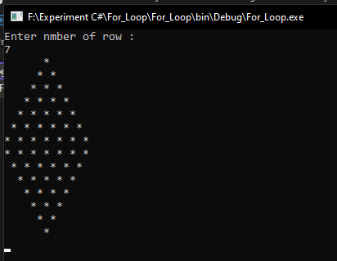**Output :**

**7.** **Foreach**

using System;

using System.Collections.Generic;

using System.Linq;

using System.Text;

using System.Threading.Tasks;

namespace @foreach

{

internal class Program

{

static void Main(string[] args)

{

int[] ar = { 1, 2, 3, 4, 5, 6, 7, 8, 9 };

foreach (int i in ar)

{

Console.WriteLine(i);

}

Console.ReadLine();

}

}

}

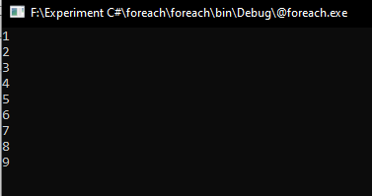**Output :**

**Name** **-** Sushant Balu Patil **Roll No**  **-** 62

**Class –** T.Y.BTech **Batch -** T3

**Experiment No : 6**

1. Static class

using System;

using System.Collections.Generic;

using System.Linq;

using System.Text;

using System.Threading.Tasks;

namespace Static

{

public static class customer

{

static int customerid;

static string customername;

static string customerorder;

static int orderprice;

public static void customerdetails()

{

Console.WriteLine("Enter Product Id : ");

customerid = Convert.ToInt32(Console.ReadLine());

Console.WriteLine("Enter Customer Name : ");

customername = Convert.ToString(Console.ReadLine());

Console.WriteLine("Enter Customer Order : ");

customerorder = Convert.ToString(Console.ReadLine());

Console.WriteLine("Enter Order Price : ");

orderprice = Convert.ToInt32(Console.ReadLine());

Console.WriteLine("---------------------------------------------------");

}

public static void orderdescount()

{

int descount;

Console.WriteLine("Hello" + " " + customername + " " + "Your Order Name Is :" + customerorder, "\n");

Console.WriteLine(customername + "Your Order Price Is :" + orderprice, "\n");

descount = orderprice / 10;

Console.WriteLine("Your Order Descount Is :" + descount, "\n");

int finalprice;

finalprice = orderprice - descount;

Console.WriteLine("Your Final Price Is :" + finalprice, "\n");

Console.WriteLine("Thank You For Visit Our Store..");

}

}

internal class Program

{

static void Main(string[] args)

{

customer.customerdetails();

customer.orderdescount();

Console.ReadLine();

}

}

}

**Output :**

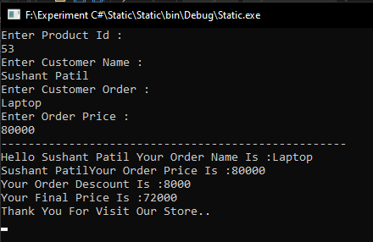

**2. Partial class**

**Program 1.**

using System;

using System.Collections.Generic;

using System.Linq;

using System.Text;

using System.Threading.Tasks;

namespace Main_Class

{

public partial class Class1

{

public void FirstName()

{

Console.WriteLine("hello, Anna..");

}

}

}

**Program 2.**

using System;

using System.Collections.Generic;

using System.Linq;

using System.Text;

using System.Threading.Tasks;

namespace Main_Class

{

public partial class Class1

{

public void FullName()

{

Console.WriteLine("hello, Sushant Patil");

}

}

}

**Main Program.**

using System;

using System.Collections.Generic;

using System.Linq;

using System.Text;

using System.Threading.Tasks;

namespace Main_Class

{

internal class Program

{

static void Main(string[] args)

{

Class1 obj = new Class1();

obj.FirstName();

obj.FullName();

Console.ReadLine();

}

}

}

**Output :**

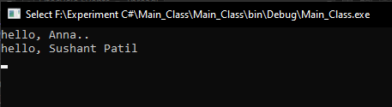

**Name** **-** Sushant Balu Patil **Roll No**  **-** 62

**Class –** T.Y.BTech **Batch -** T3

**Experiment No : 7**

**1. single dimensional:**

using System;

using System.Collections.Generic;

using System.Linq;

using System.Text;

using System.Threading.Tasks;

namespace single_dimension

{

internal class Program

{

static void Main(string[] args)

{

int[] ar =new int[5];

for(int i=0; i <= 4; i++)

{

Console.WriteLine("Enter Element At Position "+(i+1));

ar[i] =Convert.ToInt32(Console.ReadLine());

}

Console.WriteLine("------------------------------------------");

for(int i = 0; i <= 4; i++)

{

Console.WriteLine("Value At Arr["+i+"] = " + ar[i]);

}

Console.ReadLine();

}

}

}

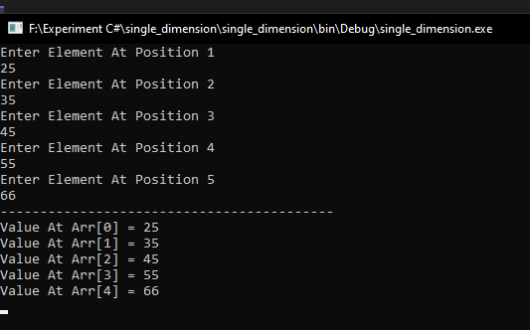**Output :**

**2. Multidimensional :**

using System;

using System.Collections.Generic;

using System.Linq;

using System.Text;

using System.Threading.Tasks;

namespace Multidimension

{

internal class Program

{

static void Main(string[] args)

{

Console.WriteLine("Enter Matrix size : ");

int n = int.Parse(Console.ReadLine());

int m = n;

int[,] a = new int[n, m];

Console.WriteLine("enter element one by one : ");

for (int i = 0; i < n; i++)

{

for (int j = 0; j < m; j++)

{

a[i, j] = Convert.ToInt32(Console.ReadLine());

}

}

Console.WriteLine("element is given below : ");

for (int i = 0; i < n; i++)

{

for (int j = 0; j < m; j++)

{

Console.Write(a[i, j] + " ");

}

Console.WriteLine(" ");

}

Console.ReadKey();

}

}

}

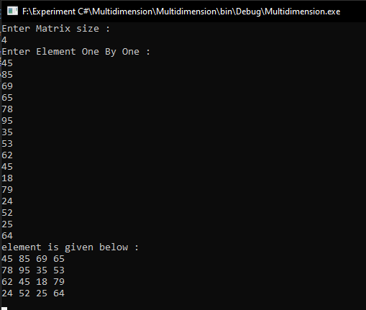**Output:**

**3.Jagged Array.**

using System;

using System.Collections.Generic;

using System.Linq;

using System.Text;

using System.Threading.Tasks;

namespace jagged_array

{

internal class Program

{

static void Main(string[] args)

{

int[][] arr = new int[3][]

{

new int[] { 11,21,56,78},

new int[] { 11,21,23,67,89},

new int[] { 11,21,}

};

for (int i = 0; i < arr.Length; i++)

{

for (int j = 0; j < arr[i].Length; j++)

{

Console.Write(arr[i][j] + " ");

}

System.Console.WriteLine();

}

Console.ReadLine();

}

}

}

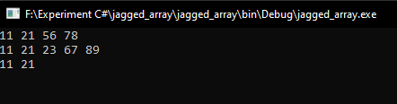**Output :**

**Name** **-** Sushant Balu Patil **Roll No**  **-** 62

**Class –** T.Y.BTech **Batch -** T3

**Experiment No : 8**

**Interface.**

using System;

using System.Collections.Generic;

using System.Linq;

using System.Text;

using System.Threading.Tasks;

namespace Interface

{

interface allarea

{

void rectangle_area();

void triangle_area();

void circle_area();

}

class angle : allarea

{

public void rectangle_area()

{

Console.WriteLine("======= Rectangle Area ========== ");

Console.WriteLine("Enter the Height : ");

int h = Convert.ToInt32(Console.ReadLine());

Console.WriteLine("Enter the Width : ");

int w = Convert.ToInt32(Console.ReadLine());

int area;

area = h * w;

Console.WriteLine("Rectangle Area = " + area);

}

public void triangle_area()

{

Console.WriteLine("========Triangel Area========");

Console.WriteLine("Enter Height : ");

double h = Convert.ToDouble(Console.ReadLine());

Console.WriteLine("Enter Base : ");

double b = Convert.ToDouble(Console.ReadLine());

double area = 0.5f * h * b;

Console.WriteLine("Area of Triangle : " + area);

}

public void circle_area()

{

Console.WriteLine("============= Area of Circle =============");

float r = 2.2f;

float area = 3.14f * r * r;

Console.WriteLine("Area of Circle : " + area);

}

}

internal class Program

{

static void Main(string[] args)

{

angle angle = new angle();

angle.rectangle_area();

angle.triangle_area();

angle.circle_area();

Console.ReadLine();

}

}

}

**Output :**

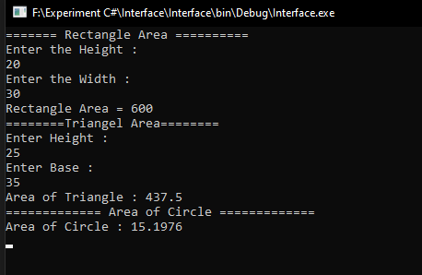

**Name** **-** Sushant Balu Patil **Roll No**  **-** 62

**Class –** T.Y.BTech **Batch -** T3

**Experiment No : 9**

**Operator Overloading.**

using System;

using System.Collections.Generic;

using System.Linq;

using System.Text;

using System.Threading.Tasks;

namespace operator_overloading

{

class complex

{

private int x;

private int y;

public complex()

{

}

public complex(int i, int j)

{

x = i;

y = j;

}

public void showxy()

{

Console.WriteLine("{0}{1}", x, y);

}

public static complex operator -(complex c)

{

complex temp = new complex();

temp.x = -c.x;

temp.y = -c.y;

return temp;

}

}

internal class Program

{

static void Main(string[] args)

{

complex c1 = new complex(10, 20);

c1.showxy();

complex c2 = new complex();

c2.showxy();

c2 = -c1;

c2.showxy();

Console.ReadLine();

}

}

}

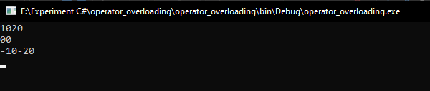**Output :**

**Name** **-** Sushant Balu Patil **Roll No**  **-** 62

**Class –** T.Y.BTech **Batch -** T3

**Experiment No : 10**

**String Operation.**

using System;

using System.Collections.Generic;

using System.Linq;

using System.Text;

using System.Threading.Tasks;

namespace String_Operation

{

internal class Program

{

static void Main(string[] args)

{

string str = "Easy Software";

Console.WriteLine(str);

Console.WriteLine("--------------ToUpper-------------------");

Console.WriteLine(str.ToUpper());

Console.WriteLine("______________Tolower_____________________");

Console.WriteLine(str.ToLower());

Console.WriteLine("--------------length of string--------------");

Console.WriteLine(str.Length);

Console.WriteLine("--------------charAt 2 index---------------");

Console.WriteLine(str[2]);

Console.WriteLine("-------------startswith So------------------");

Console.WriteLine(str.StartsWith("So"));

Console.WriteLine("--------------Endswith re---------------------");

Console.WriteLine(str.EndsWith("re"));

Console.WriteLine("--------------CompareTo----------------------");

Console.WriteLine(str.CompareTo("Easy Software"));

Console.WriteLine(str.CompareTo("Easy software"));

Console.WriteLine("--------------Equals----------------------");

Console.WriteLine(str.Equals("easy software"));

Console.WriteLine(str.Equals("Easy Software"));

Console.WriteLine("--------------replace-----------------------");

string newstr = str.Replace("Easy", "hard");

Console.WriteLine(newstr);

Console.ReadLine();

}

}

}

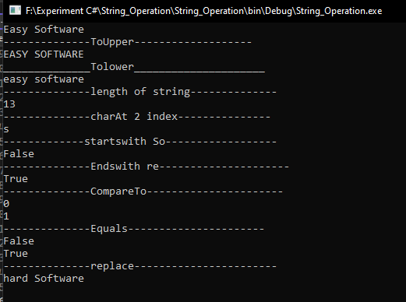**Output :**

**String Builder Method.**

using System;

using System.Collections.Generic;

using System.Linq;

using System.Text;

using System.Threading.Tasks;

namespace String_Builder

{

internal class Program

{

static void Main(string[] args)

{

StringBuilder sb = new StringBuilder("hello");

Console.WriteLine(sb);

Console.WriteLine("--------------Append Method---------------");

Console.WriteLine(sb.Append("world"));

Console.WriteLine("--------------Remove Method-------------------");

sb.Remove(2, 3);

Console.WriteLine(sb);

Console.WriteLine("--------------Insert Method-------------------");

Console.WriteLine(sb.Insert(2, "XYZ"));

Console.WriteLine("--------------Replace Method-------------------");

Console.WriteLine(sb.Replace("hello", "hi"));

Console.WriteLine("--------------Equals Method--------------------");

StringBuilder sb2 = new StringBuilder("hello");

Console.WriteLine(sb.Equals(sb2));

Console.WriteLine("--------------Clear Method------------------");

Console.WriteLine(sb.Clear());

Console.ReadLine();

}

}

}

**Output :**

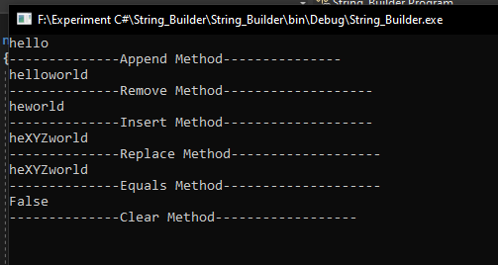

**Name** **-** Sushant Balu Patil **Roll No**  **-** 62

**Class –** T.Y.BTech **Batch -** T3

**Experiment No : 11**

**Exception Handling.**

using System;

using System.Collections.Generic;

using System.Linq;

using System.Text;

using System.Threading.Tasks;

namespace Exceptional_Handling

{

internal class Program

{

static void Main(string[] args)

{

float x, y, z;

try

{

Console.WriteLine("Enter first number");

y = Convert.ToInt32(Console.ReadLine());

Console.WriteLine("Enter second number");

z = Convert.ToInt32(Console.ReadLine());

if (z != 0)

{

x = y / z;

Console.WriteLine("Div=" + x);

}

else

{

throw new Exception("Don't put zero in denominator");

}

}

catch (Exception e)

{

Console.WriteLine("Error:" + e);

}

Console.ReadKey();

}

}

}

**Output :**

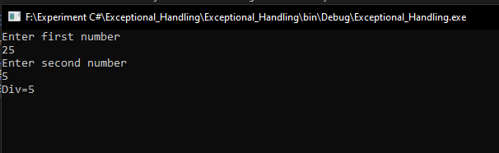

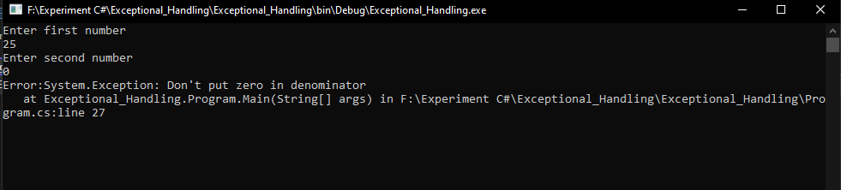

**Name** **-** Sushant Balu Patil **Roll No**  **-** 62

**Class –** T.Y.BTech **Batch -** T3

**Experiment No : 12**

**Multithreading.**

using System;

using System.Collections.Generic;

using System.Linq;

using System.Text;

using System.Threading;

using System.Threading.Tasks;

namespace Multithreading

{

internal class Program

{

static void Main(string[] args)

{

Thread mainThread = Thread.CurrentThread;

mainThread.Name = " main thread";

Console.WriteLine(mainThread.Name);

countdown();

countup();

Console.WriteLine(mainThread.Name + " is completed");

Console.ReadKey();

}

public static void countdown()

{

for (int i = 10; i >= 0; i--)

{

Console.WriteLine("timer #1: " + i + " seconds");

Thread.Sleep(1000);

}

Console.WriteLine("timer #1 is complete..!");

}

public static void countup()

{

for (int i = 0; i <= 10; i++)

{

Console.WriteLine("timer #2: " + i + " seconds");

Thread.Sleep(1000);

}

Console.WriteLine("timer #2 is complete..!");

}

}

}

**Output :**

